**PROJECT REPORT TEMPLATE**

**1. Introduction**

1.1 Overview

A brief description about your project

1.2 Purpose

The use of this project. What can be achieved using this.

**2. Problem definition & design thinking**

2.1 Empathy Map

Past the empathy map screenshot

2.2 Ideation & Brainstorming Map

Past the ideation & Brainstorming map screenshot

**3. Result**

Final finding (output) of the project along with screenshots.

**4. Advantages & Disadvantages**

List of advantages and disadvantages of the proposed solution.

**5. Applications**

The areas where this solution can be applied.

**6. Conclusion**

Conclusion summarizing the entire work and findings.

**7. Future scope**

Enhancements that can be made in the future.

**8. Appendix**

A. source code

Attach the code for the solution built

1. **INTRODUCTION**
   1. A brief description about your projects.

Let us analyze the Indian agriculture crop production for the data collected from 1997 to 2022. Let us ask interesting questions on existing data get production and area statistics and understand more on the Indian agriculture history for crop production.

* 1. The use of this projects.

The populations of India mostly depend on the agriculture. Tthis projects useful to analysis how much crops are grown in each state and how are they affected by environmental condition.

1. **Problem definition & design thinking**
   1. Past the empathy map screenshot.:

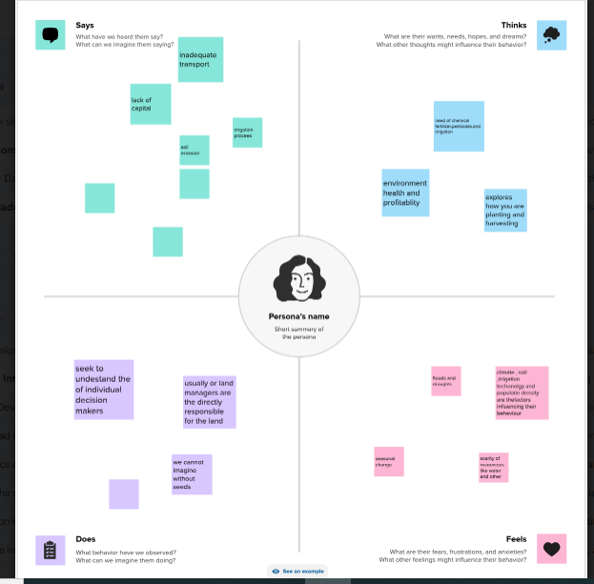

2.2 Past the ideation & brainstorming map screenshot:

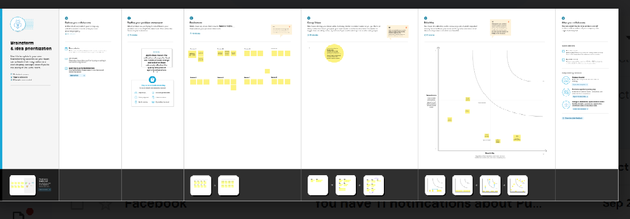

**3. Result**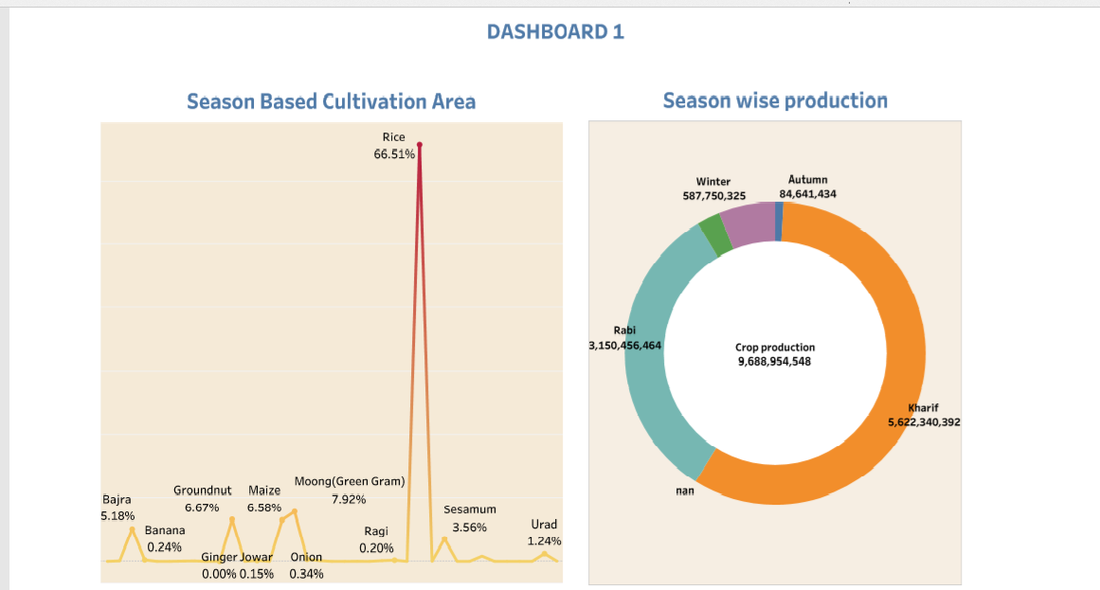

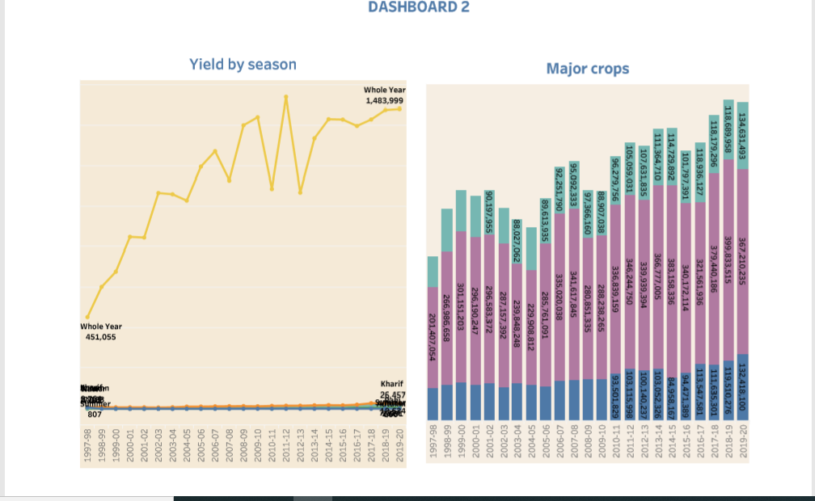

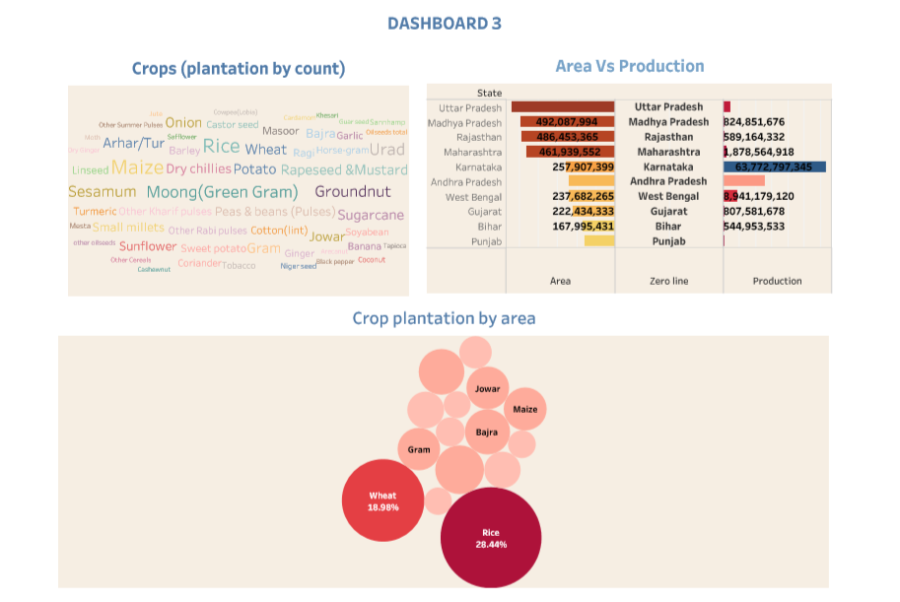

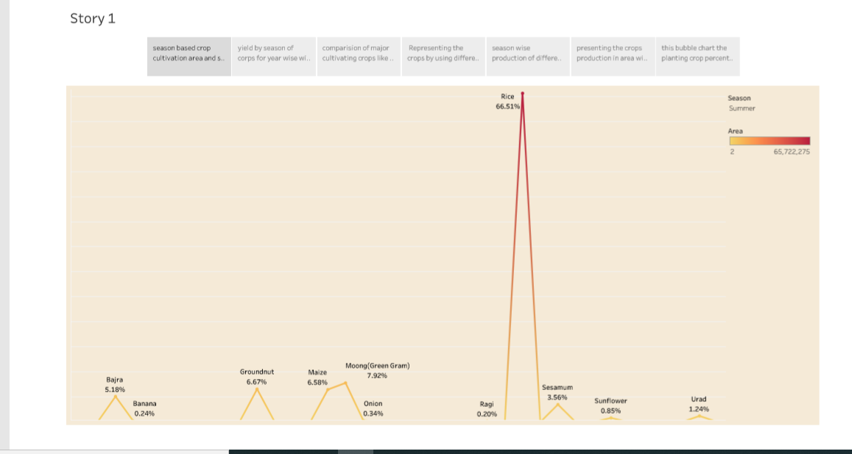

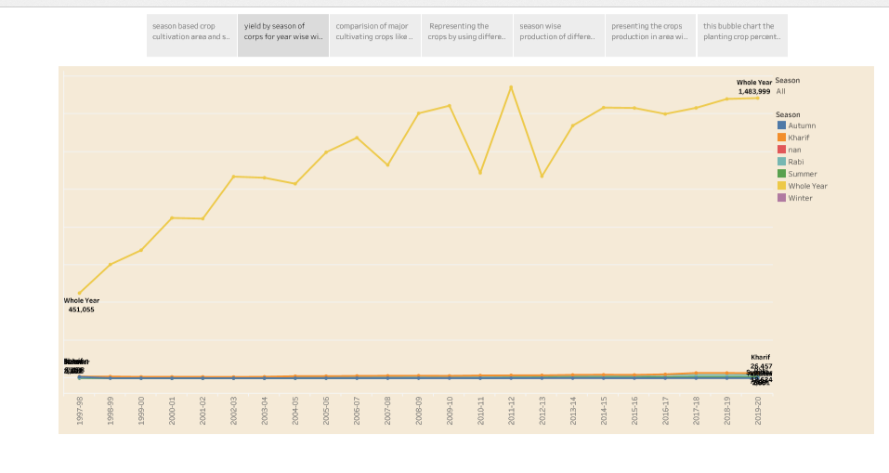

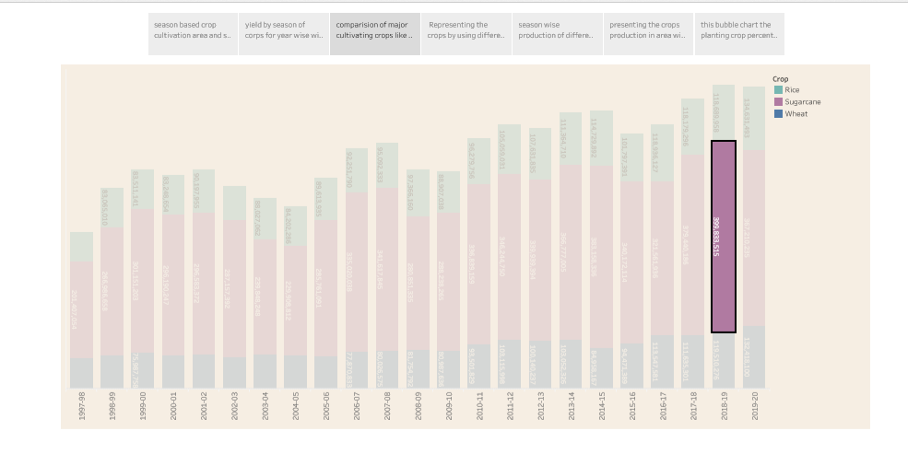

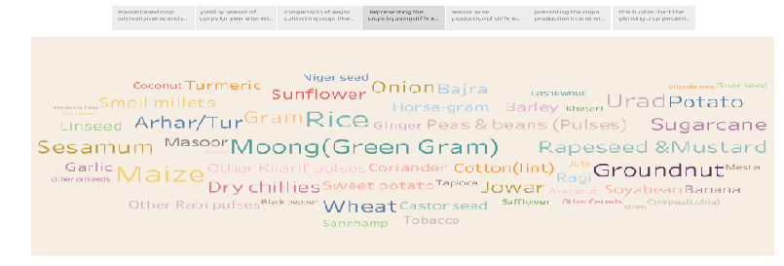

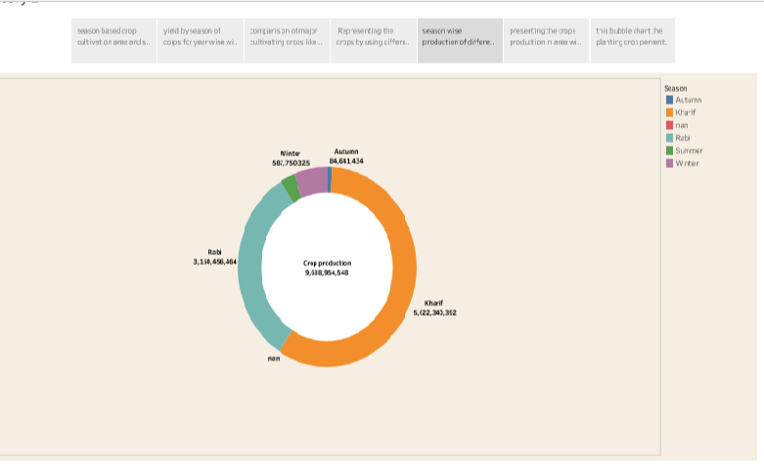

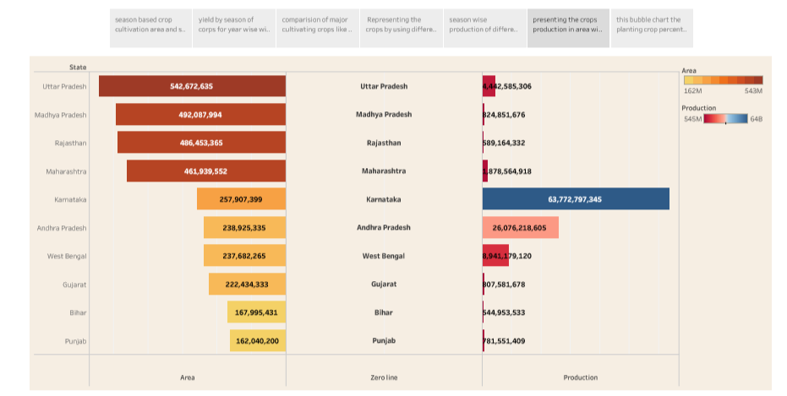

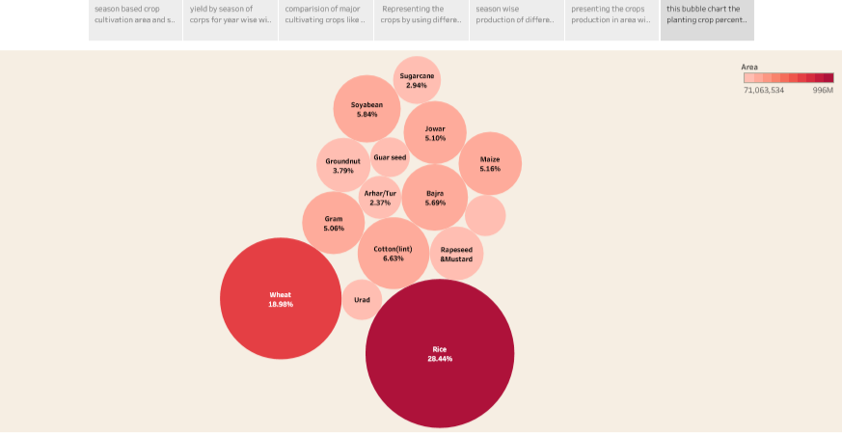

**4.Advantages and disadvantages**

|  |  |
| --- | --- |
| **ADVANTAGES** | **DISADVANTAGES** |
| 1. Increased efficiency 2. Improved crop quality 3. Reduced environmental impact 4. Increased food production 5. Economic benefits | 1. Soil degradation 2. Biodiversity loss 3. Water pollution 4. Health risks 5. Food safety concerns |

**5. Applications:**

* Copying of animals to produce embryos and live animals.
* Increase food and nutrition security and food production and processing.
* Agricultural biotechnology has been used to improve the nutritional content of a variety of crops in an effort to meet the needs of an increasing populations.

**6. Conclusion:**

The Indian economy is an agro-economy and depends highly on the agricultural sector. Despite just supporting the Indian economy, the agricultural sector also supports the industrial sector and international trade in imports and exports.

**7. Future scope:**

There is a tremendous scope for agriculture because food and food products are indispensable for the survival of humanity. Future agricultural will use sophisticated technologies such as robots, temperature and moisture sensors, aerial images, and GPS techonology.